

MAULANA ABUL KALAM AZAD UNIVERSITY OF TECHNOLOGY,

WEST BENGAL

NH-12 (Old NH-34), Simhat, Haringhata, Nadia -741249

DEPARTMENT OF INFORMATION TECHNOLOGY
Subject: Data Structure & Algorithm using Python(1st assignment)

NAME: LOKESH GHOSH
COURSE: BCA (2nd Year/3rd Sem)
ROLL NO: 30001220008
REG. NO: 203001001210008
MAIL ID: ghoshlokesh57@gmail.com
PHONE NO: 9775140484
BATCH: 2020-2021

1)Write a python program to print the following pattern
*
* *
* * *
* * * *
* * * * *

Input:
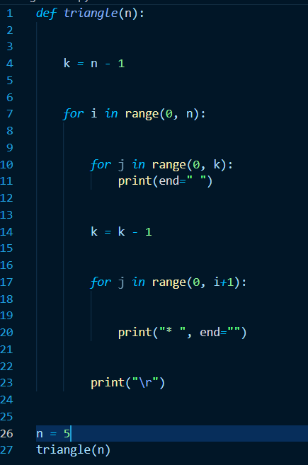

Output:
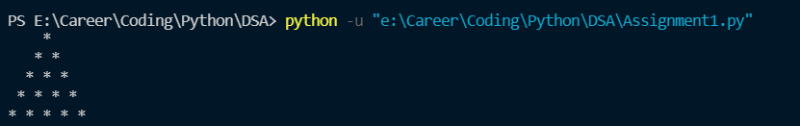

2. Write a python program to print Pyramid of Natural Numbers Less than 10
Pattern:
1
2 3 4
5 6 7 8 9

Input: 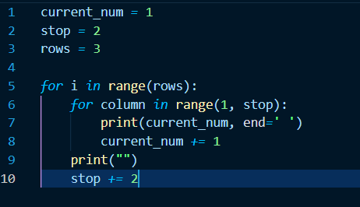

Output:

3. )Write a Python program to print the Fibonacci series.

Input:
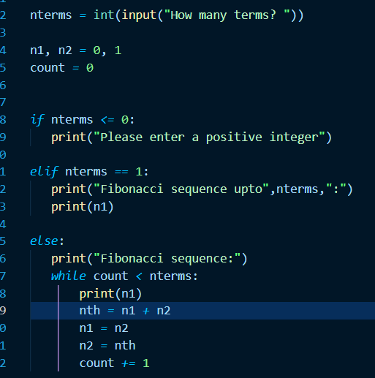

Output:
